NAME= WANIA HASEEB

NUMBER GUESSING GAME

CODE

#include <math.h>

#include <stdio.h>

#include <stdlib.h>

#include <time.h>

int main()

{

int lower, upper, x, guess, count = 0, flag = 0;

int total_chances;

// Taking Inputs

printf("Enter Lower bound: ");

scanf("%d", &lower);

// Taking Inputs

printf("Enter Upper bound: ");

scanf("%d", &upper);

// Seed the random number generator

srand(time(0));

// Generating random number between the lower and upper

x = (rand() % (upper - lower + 1)) + lower;

total_chances

= (int)ceil(log(upper - lower + 1) / log(2));

printf("\n\tYou've only %d chances to guess the "

"integer!\n\n",

total_chances);

// for calculation of minimum number of guesses depends

// upon range

while (count < total_chances) {

count++;

// Taking guessing number as input

printf("Guess a number: ");

scanf("%d", &guess);

// Condition testing

if (x == guess) {

printf(

"Congratulations you did it in %d try!\n",

count);

// Once guessed, loop will break

flag = 1;

break;

}

else if (x > guess) {

printf("You guessed too small!\n");

}

else if (x < guess) {

printf("You guessed too high!\n");

}

}

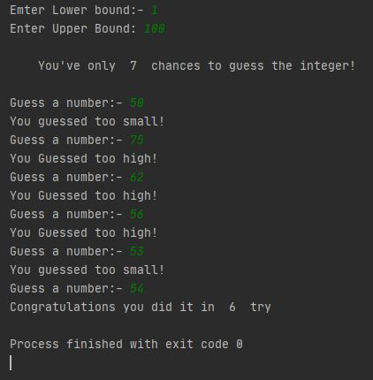

// If Guessing is more than required guesses, shows this

// output.

if (!flag) {

printf("\nThe number is %d\n", x);

printf("\tBetter Luck Next time!\n");

}

return 0;

}